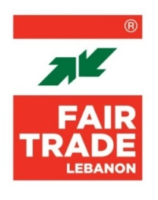
TERMS OF REFERENCE

Title: Cow Compost Manure

Location: Lebanon
Project Title: Food for Akkar
Procurement Project to be submitted by: 14 March 2024
Dead line related to the posting: 7 March 2024

Contact: procurement@fairtradelebanon.org

SCOPE OF WORK

- Summary
Fair Trade Lebanon is looking for suppliers to provide Compost Manure to Owaynat- Akkar.

- Objective
Reinforcing food security in Akkar through the improvement of the production capacities of farmers and a better access to food for vulnerable communities.

- Technical Specifications
Item: Cow Compost Manure
Description: Cow based
Unit: Ton
Quantity: 32
Specification: Locally produced

- Requirements & conditions
The service provider is required to deliver all items to Al-Owaynat-Akkar along with workers/helpers available to assist with loading and unloading products, as and whenever needed.
- Company qualification
The company must have the following valid legal documents:
- Commercial Circular
- Fiscal Certificate of Incorporation at the Ministry of Finance
- VAT Certificate of Registration if applicable
- ID of company’s authorized representative(s)
- Evaluation

- The quotation’s evaluation process will consider following with assigned weights:
- Financial ......................................... 50%
- Technical ........................................ 40%
- Reputation & Reference Check ...... 10%

- Payment Terms
- The payments are subject to the availability of funds from the donor, and will be made upon the successful transfer of the due amount by the donor.
- Payments will be made only through bank transfer or bank cheques, within 15 business days of invoice receipt.
- The price will be paid in USD while the VAT will be paid in LBP based on the official exchange rate on the date of the invoice.

- How to apply
- Detailed offer and all legal documents to be submitted via email to: procurement@fairtradelebanon.org
- Only selected candidates will be contacted

