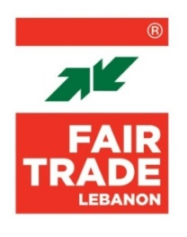
TERMS OF REFERENCE

Develop Training Curriculum

Location: Lebanon – Beirut
Type of Contract: Consultant
Starting Date: March 2023
End Date: April 2023
Languages: Arabic and English
Reports to: FTL Project Manager
Coordinates with: FTL Project Coordinator
Project Title: NOOMOO
Deadline: 20 February 2023
Contact: careers@fairtradelebanon.org

SCOPE OF WORK

- Objective

Fair Trade Lebanon, in partnership with GIZ, is proposing to implement an incubation program supporting agri-food 25 MSMEs and cooperatives in Beirut and Mount Lebanon. The project will be conducted over a period of 18 months. Funded by BMZ, the program is designed to help the participants grow their businesses and refine their activities by offering them training sessions, customized coaching, and capacity building in business-related topics.

- Scope of work

The consultant will develop the training curriculum for the project, including:
- Market access
- Sales
- Food packaging and labelling
- Marketing management
- Certifications
- Finance for start-ups and access to finance
- Product development and innovation
- Mitching
- PWD inclusion
- Business plan

- Deliverables

- To develop training curriculum for the identified topics

- Qualifications

- Higher university degree in business, economics, finance
- Minimum 5 years’ experience as a consultant
- Able to develop clear and well-structured curriculum
- Proven knowledge of Fair-Trade principles
- In depth knowledge of the Lebanese context
- Proven presentation skills
- Drives results

- Skills

- Adheres to FTL values
- Good interpersonal communication skills
- Engaged in developing self and others
- High degree of self-motivation
- Excellent leadership, team building, and management skills
- Good time management
- Organized and able to create multiple timelines and schedules
- Good knowledge of Arabic and English

