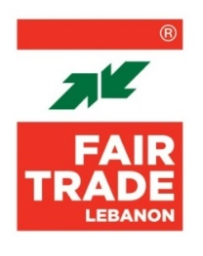
TERMS OF REFERENCE

Coaching Business Plan Presentation

Location: Lebanon – Beirut
Type of Contract: Consultant
Starting Date: 1 September 2023
End Date: 31 December 2023
Languages: Arabic and English
Reports to: FTL Project Manager
Coordinates with: FTL Project Coordinator
Project Title: NOOMOO
Deadline: 12 August 2023
Contact: careers@fairtradelebanon.org

SCOPE OF WORK

- Objective

Fair Trade Lebanon, in partnership with GIZ, is proposing to implement an incubation program supporting agri-food 25 MSMEs and cooperatives in Beirut and Mount Lebanon. The project will be conducted over a period of 18 months. Funded by BMZ, the program is designed to help the participants grow their businesses and refine their activities by offering them training sessions, customized coaching, and capacity building in business-related topics.

- Scope of work

The consultant will produce a business model presentation for each of the 25 MSMEs. The consultant will coordinate with the business plan development expert.

- Deliverables

The consultant will submit a presentation for each of the 25 MSMEs, summarizing the business plan.

- Qualifications

- Higher university degree in business, economics, finance
- Minimum 3 years’ experience as a consultant for SMEs
- Proven knowledge of Fair-Trade principles
- In depth knowledge of the Lebanese context
- Proven presentation skills
- Drives results

- Skills

- Adheres to FTL values
- Project management skills (mid-level)
- Good interpersonal communication skills
- Problem solving skills
- Quality assurance
- Adaptability
- Feedback management
- Time management
- Technology proficiency (calendar tools, Word and PowerPoint)
- Organized and able to create multiple timelines and schedules
- Good knowledge of Arabic and English (French is a plus)

